
Kinnaird College for Women University

Pre-mid Assignment

Submitted to: Mam Mamoona Nawaz
Submitted by: Saliha Mubeen
Roll no: F25BSCS056
Section: B
Date: 27/02/2026

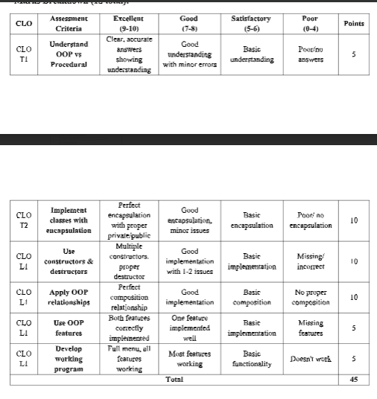

QUESTION NO 1 :

EXPLANATION OF THE GIVEN CODE :

In this program, I created a Smart Room Manager using object-oriented programming to manage devices like lights in an organized way
.I started by making a Device class to represent each unit. I kept the name, status, and brightness levels private to follow encapsulation, meaning they can’t be accessed directly from outside the class.
To manage this data, I used setter and getter functions. I also included both default and overloaded constructors, along with a destructor that prints a message whenever a device object is removed, which helps show exactly when objects are being destroyed in memory.
Next, I built a Room class that can hold up to five devices using an array of objects rather than pointers. This class includes the logic to add devices, display them all, find a specific one by name, or update their power and brightness.
I used a count variable to keep track of how many devices are currently in the room at any time.
The main function ties everything together with a menu-driven system. It runs in a loop so you can keep adding or updating devices until you choose to exit, making the program easy to use and interactive.
Overall, this project was a great way to practice OOP concepts like constructors, destructors, and arrays of objects by applying them to a real-life management system.

Code: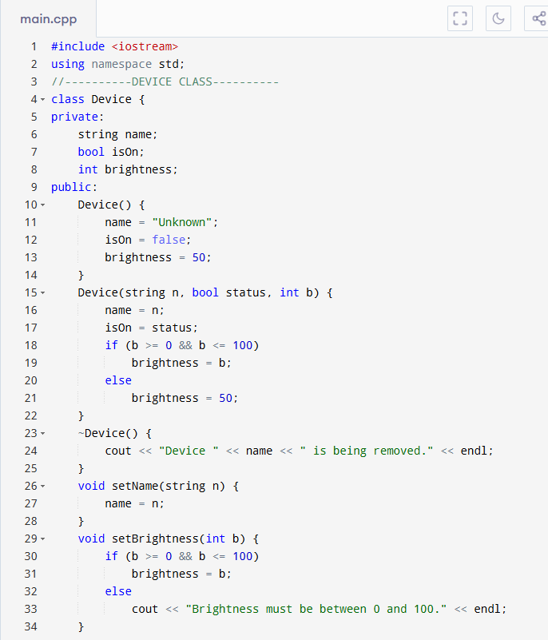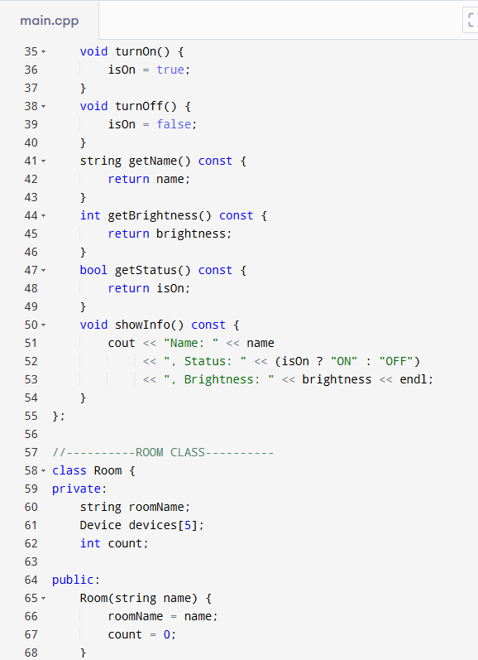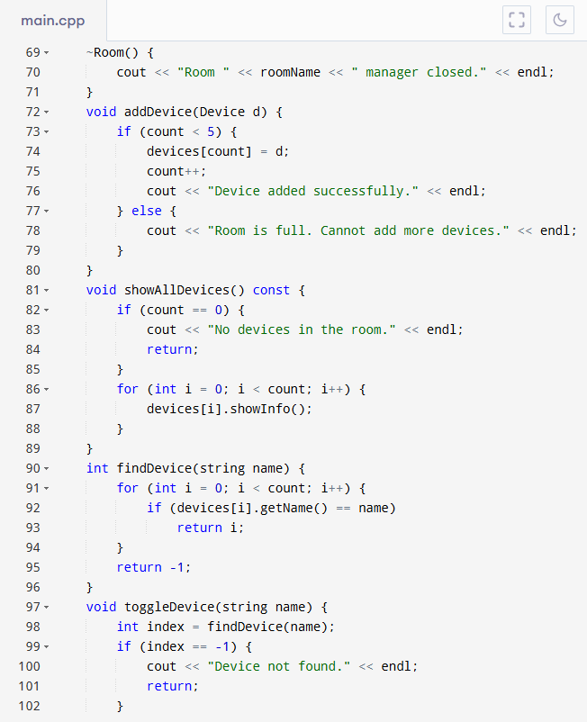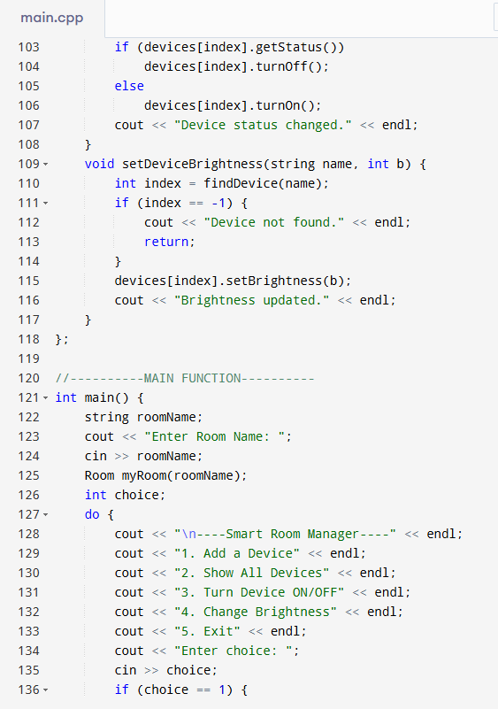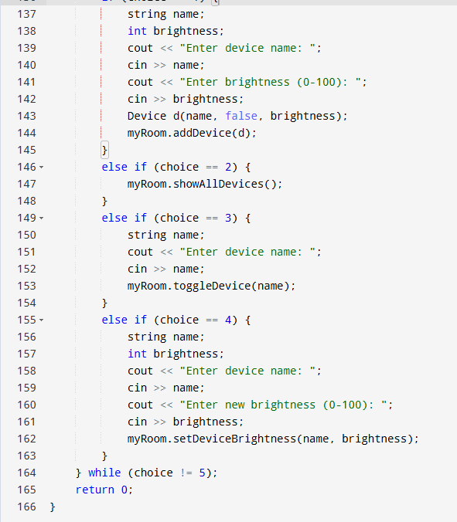

Question 2

1. Main Classes with Responsibilities
- Product
Represents an item that is sold on the website.
- Customer
Represents a user who buys products and has purchase history.
- ShoppingCart
Temporarily stores products before placing an order.
- Order
Represents a confirmed purchase made by a customer.
- Payment
Handles the payment process for an order.

2. Key Data Members (Attributes)
- Product
- name
- id
- price
- stockQuantity
- Customer
- name
- email
- purchaseHistory
- ShoppingCart
- list of products
- Order
- list of products
- totalAmount
- status
- Payment
- amount
- paymentMethod
- paymentStatus

3. Key Member Functions (Methods)
- Product
- updateStock()
- displayProduct()
- Customer
- addToCart()
- placeOrder()
- ShoppingCart
- addProduct()
- removeProduct()
- Order
- calculateTotal()
- updateStatus()
- Payment
- processPayment()
- confirmPayment()
4. Show how these classes relate (e.g., composition, aggregation) by drawing a simple
UML-like diagram or describing the relationships.
Customer has a shoppingCart-composition
Customer has orders-aggregation
- Shoppingcart has products- aggregation
- Order has products-aggregation
- Order has a payment-composition
- Write the skeleton structure of one class in C++ (only class definition with private and public sections, no implementation).
- class Product{
- private:
- int productID;
- string name;
- double price;
- int stockQuantity;
- public:
- void setProduct(int id,string n, double p, int stock )
- int getProductID( ):
- string getName():
- double getPrice( );
- int getStockQuantity();
- void updateStock(int quantity);
- void displayProduct();
CONCLUSION :
In conclusion, object-oriented programming helps organize the E-commerce system into different classes. Each class has its own responsibility. This makes the system more structured, secure, and easy to manage.

